TODAY ASSIGNMENT(1/07/2020)

1. Calculate bill amount of patient and retrieve patient details

//patient.java

**package** jdbcapp.com;

**import** java.sql.Connection;

**import** java.sql.DriverManager;

**import** java.sql.ResultSet;

**import** java.sql.SQLException;

**import** java.sql.Statement;

**import** java.util.Scanner;

**public** **class** patient {

**public** **static** **void** main(String[] args){

// **TODO** Auto-generated method stub

Scanner sc= **new** Scanner(System.***in***);

**int** days;

System.***out***.println("Enter no days patient to be stayed in hospital");

days=sc.nextInt();

System.***out***.println("Enter list of medicines");

**int** list=sc.nextInt();

System.***out***.println("Enter cost of room rent per day");

**int** cost=sc.nextInt();

**int** sum=0;

**int** []arr = **new** **int**[list];

System.***out***.println("Enter Cost of medicines");

**for**(**int** i=0;i<list;i++) {

arr[i]=sc.nextInt();

sum=sum+arr[i];

}

**int** totalCost;

totalCost=(days*cost)+sum;

String uid="dbuser";

String pwd = "1234";

String url = "jdbc:oracle:thin:@localhost:1521/XE";

Connection con;

**try**{

//load class dynamically

Class.*forName*("oracle.jdbc.driver.OracleDriver");

con = DriverManager.*getConnection*(url, uid, pwd);

System.***out***.println("Connected");

ResultSet rs ;

Statement stmt=con.createStatement();

//insert employee record into database

String qry="INSERT INTO patient VAlUES('5','prasanna','kadhukur',0)";

**int** i2=stmt.executeUpdate(qry);

System.***out***.println(i2);

rs = stmt.executeQuery("Select * from patient where pid='5'");

System.***out***.println("read patient details from database");

**while**(rs.next()){

System.***out***.println("Patient Id : " + rs.getString("pid") + ", Name : " + rs.getString("pname") + ", Address : " + rs.getString("paddress")+" Total Amount : "+totalCost);

}

con.close();

System.***out***.println("Disconnected");

}

**catch**(java.lang.ClassNotFoundException e) {

System.***out***.println("Oracle Driver not found");

}

**catch**(SQLException ex) {

System.***out***.println("SQLException:" + ex.getMessage());

}

}

Table :

create table patient(pid varchar2(20) primary key,pname varchar2(20) not null,paddress varchar2(20) not null,pbill number(20));

output:

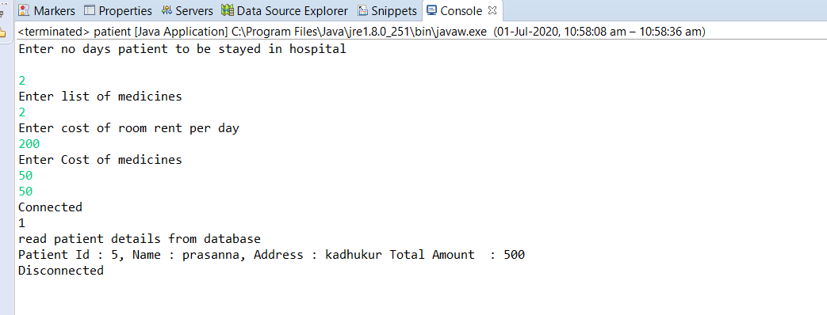

1. Insert , delete, update operations using jdbc

Employee.java

package jdbcapp.com;

import java.sql.Connection;

import java.sql.Date;

import java.sql.DriverManager;

import java.sql.ResultSet;

import java.sql.SQLException;

import java.sql.Statement;

import oracle.sql.DATE;

public class Employee {

public static void main(String[] args) {

// TODO Auto-generated method stub

String uid="dbuser";

String pwd = "1234";

String url = "jdbc:oracle:thin:@localhost:1521/XE";

Connection con;

try {

//load class dynamically

Class.forName("oracle.jdbc.driver.OracleDriver");

con = DriverManager.getConnection(url, uid, pwd);

System.out.println("Connected");

ResultSet rs ;

Statement stmt=con.createStatement();

try {

//insert employee record into database

String qry="INSERT INTO Employee VALUES(1,'prasuna',TO_DATE('25/07/1999','dd/mm/yyyy'),250000,'1234567890')";

int i2=stmt.executeUpdate(qry);

if(i2>0) {

System.out.println("After Insertion");

rs = stmt.executeQuery("Select * from employee");

System.out.println("read employee records from database");

while(rs.next()){

System.out.println("Emp Id : " + rs.getInt("empid") + ", Name : " + rs.getString("ename") + ", Date of Birth : " + rs.getDate("dob")+" salary : "+rs.getInt("salary")+" phone no : "+rs.getString("phone"));

}

}else {

System.out.println("Insertion Failed");

}

}catch(SQLException e) {

System.out.println("unique key value vialotation " + e.getMessage());

}catch(IllegalArgumentException e) {

System.out.println("Invalid date format "+e.getMessage());

}

//update employee record into database

String qry5= "Update employee set salary=31000 where empid=2";

int i1= stmt.executeUpdate(qry5);

if(i1>0) {

System.out.println("Rows updated successfully");

System.out.println("After Update");

//read employee records from database

rs = stmt.executeQuery("Select * from employee");

System.out.println("read employee records from database");

while(rs.next()){

System.out.println("Emp Id : " + rs.getInt("empid") + ", Name : " + rs.getString("ename") + ", Date of Birth : " + rs.getDate("dob")+" salary : "+rs.getInt("salary")+" phone no : "+rs.getString("phone"));

}

}else {

System.out.println("Row is Not Updated Succesfully");

}

//delete employee record from database

String qry6 = "delete from Employee where empid =18";

int i=stmt.executeUpdate(qry6);

System.out.println(i);

if(i>0) {

System.out.println("Row deleted succesfully");

System.out.println("After Deletion" );

rs = stmt.executeQuery("Select * from employee");

System.out.println("read employee records from database");

while(rs.next()){

System.out.println("Emp Id : " + rs.getInt("empid") + ", Name : " + rs.getString("ename") + ", Date of Birth : " + rs.getDate("dob")+" salary : "+rs.getInt("salary")+" phone no : "+rs.getString("phone"));

}

}else {

System.out.println("Please Enter valid Row");

}

con.close();

System.out.println("Disconnected");

}

catch(java.lang.ClassNotFoundException e) {

System.out.println("Oracle Driver not found");

}

catch(SQLException ex) {

System.out.println("SQLException:" + ex.getMessage());

}

}

}

Table :

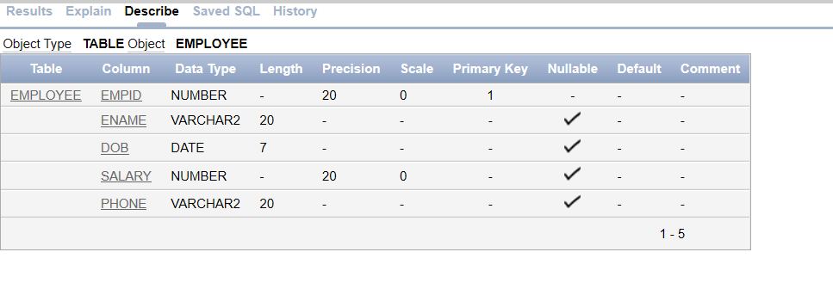

Output :

